

**SANYO SAP-KR543E**

**Rs. 286,400/-**

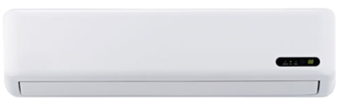

**Product Features**

* Air Vane Technology
* Auto Swing
* power mode
* precise system control technology
* concealed LED display

**Specification**

**Type** Wall Mounted Split AC

**Cooling (Btu/h)** 48000

**Voltage (V)** 220-240

**Power Input (W)** 3600

**EER (Btu/W-h-W/W)** 4.1-1.4